**Week 4 Assignment – Database Development and Class Registration**

Vicki Kelm

The University of Arizona Global Campus

CST 499: Capstone for Computer Software Technology

Dr. Amjad Alkilani

January 21, 2024

**Week 4 Assignment – Database Development and Class Registration**

This paper will show the steps in creating the remaining pages for registering for courses, listing enrolled courses for student, adding/removing courses from student, tables and functions for the student enrollment project. Below are several screenshots of the week 3 pages created: landing, login, and registration pages, table layout before adding and after removing courses, layout, and source code for the new pages created.

**Generate screenshots of the database and tables created – include the database before and after each key operation showing the success of the implementation**

**Database:**

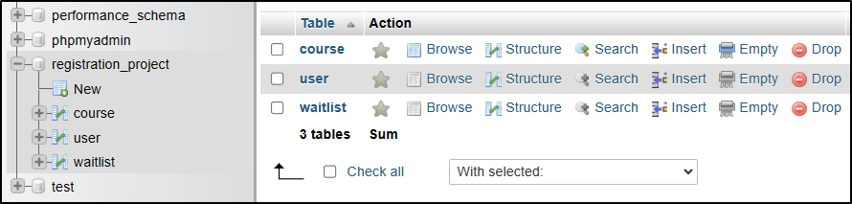

**Tables: Course and User**

**course Table:**

**Before students are enrolled:**

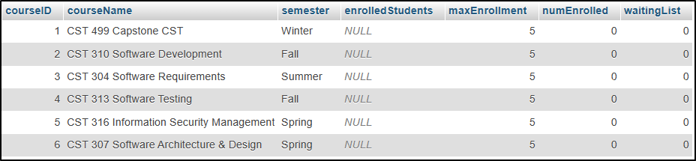

**After students are enrolled:**

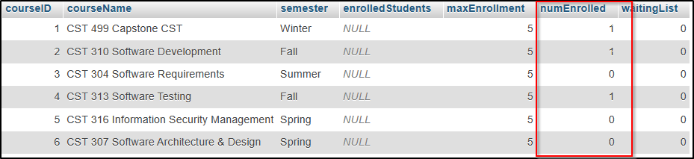

**After course removed from student Richard Kelm:**

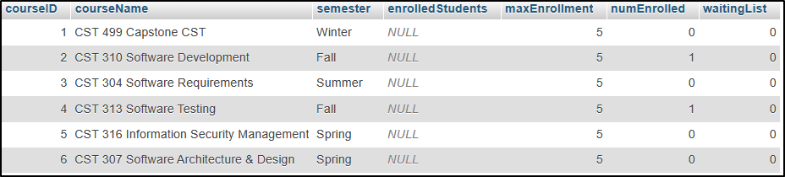

**user Table:**

**Before courses are enrolled:**

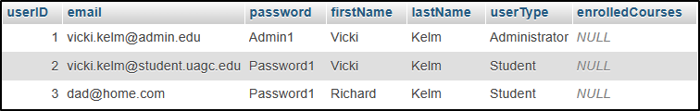

**After courses are enrolled:**

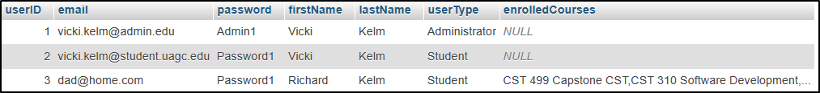

**After removed course: CST 499 Capstone CST**

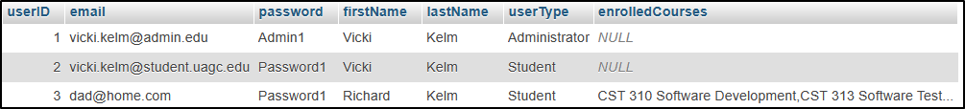

**Generate screenshots of the different pages created**

**Landing Page:**

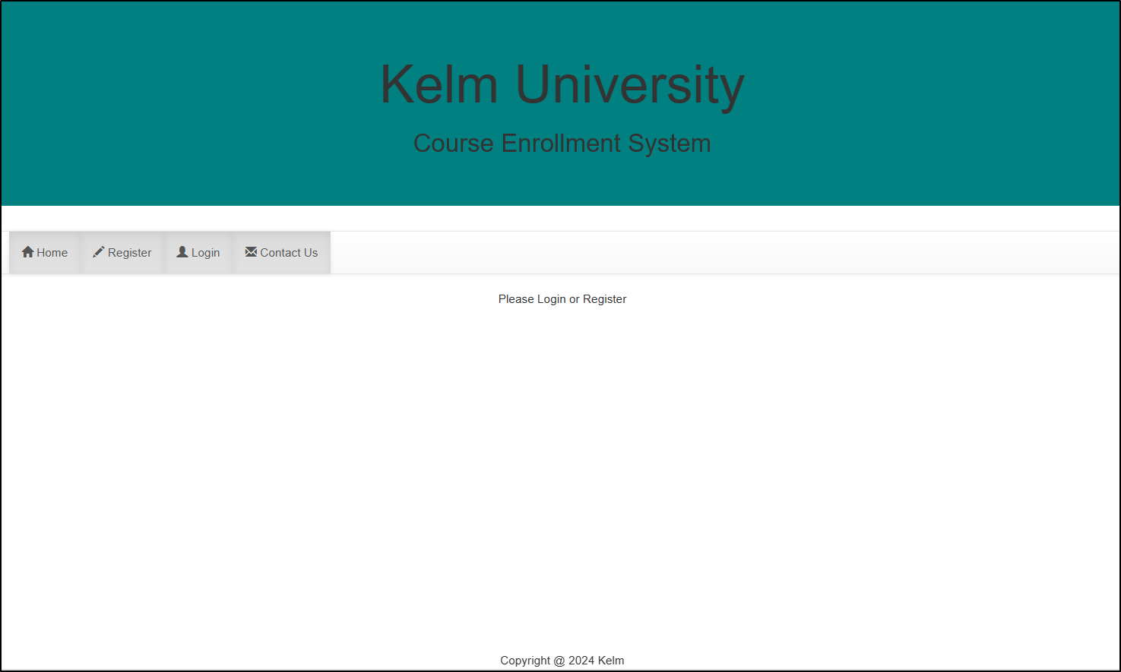

**Login Page:**

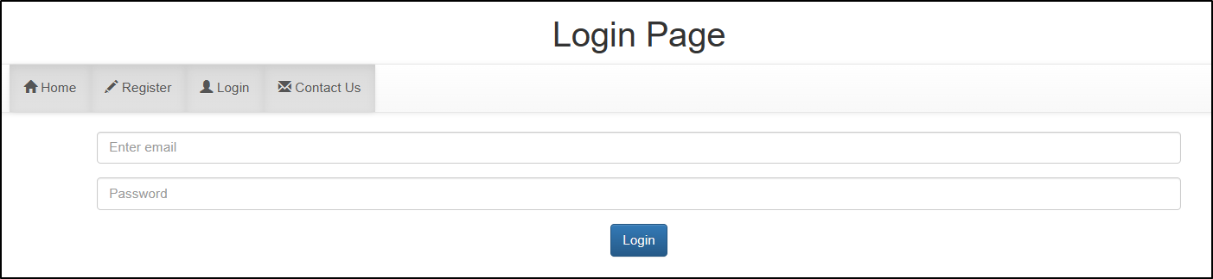

**Registration Page:**

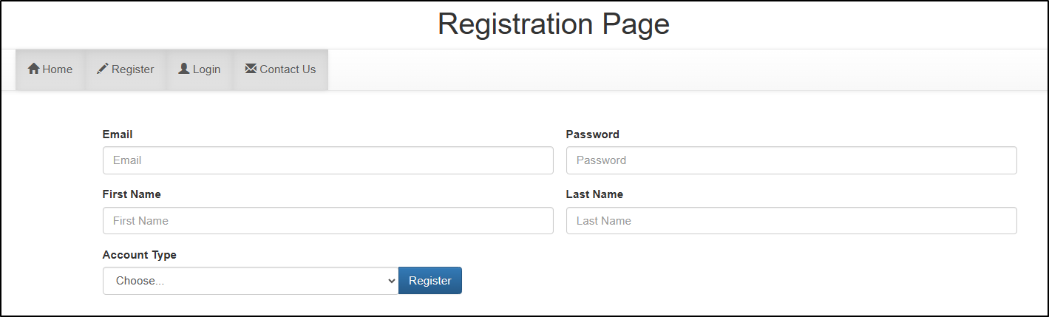

**Profile Page:**

**After enrolling in courses:**

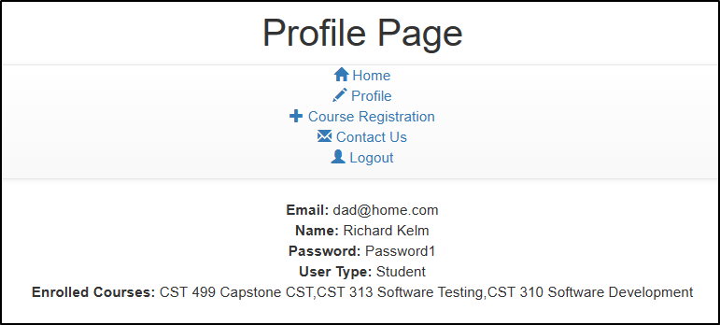

**After removing a course: CST 499 Capstone CST**

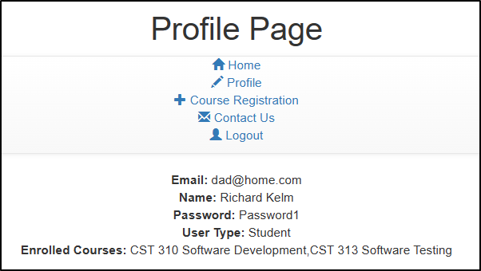

**Course Registration Page:**

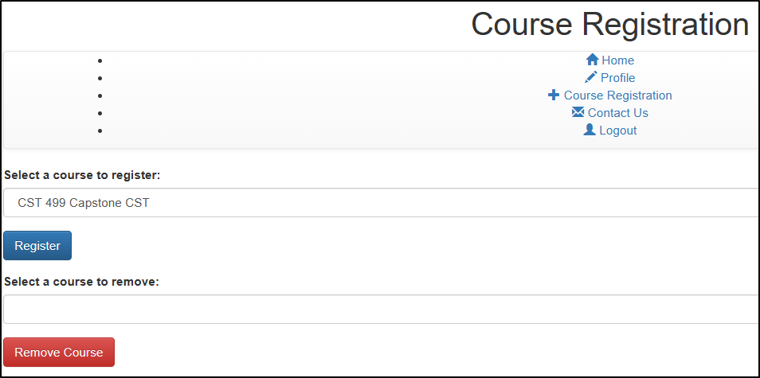

**Contact Us Page:**

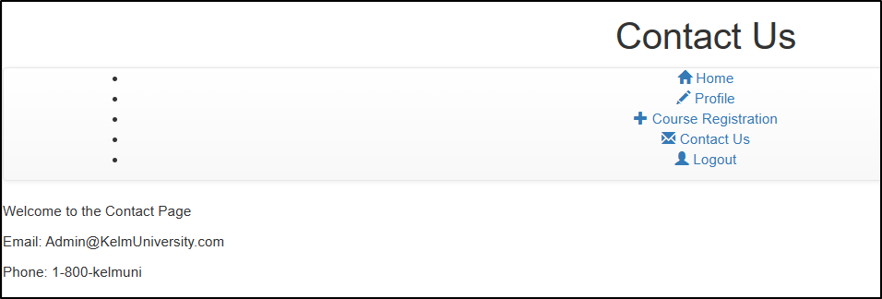

**Admin Page:**

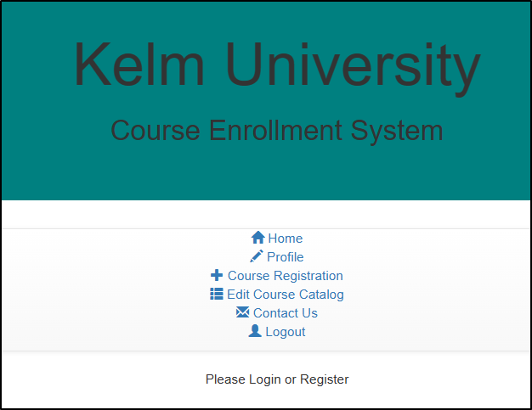

**Edit Course Catalog Page (Admins ONLY):**

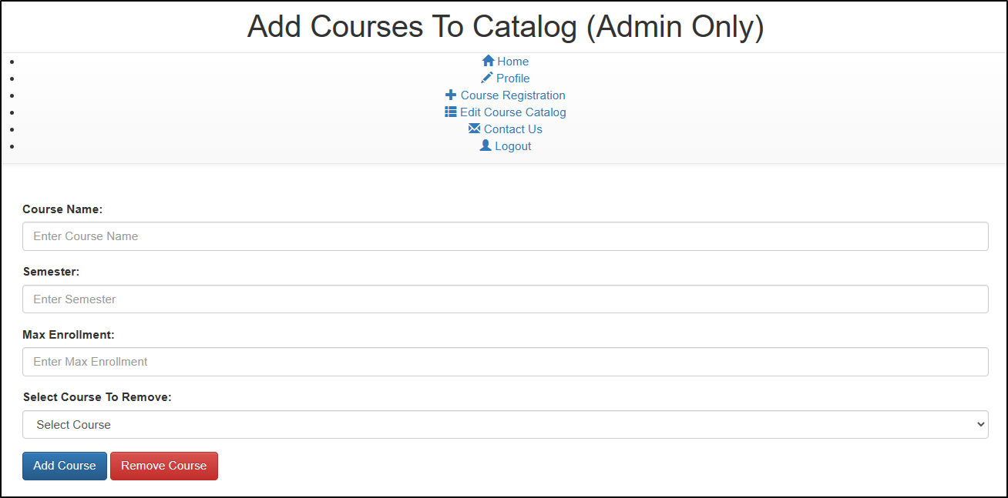

**Generate screenshots of the PHP code to implement the logic**

**Database and table: registration_project DB, user Table, course Table**

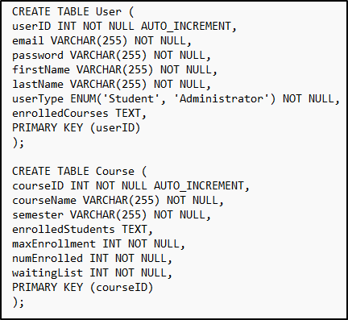

**Profile Page PHP Code:**

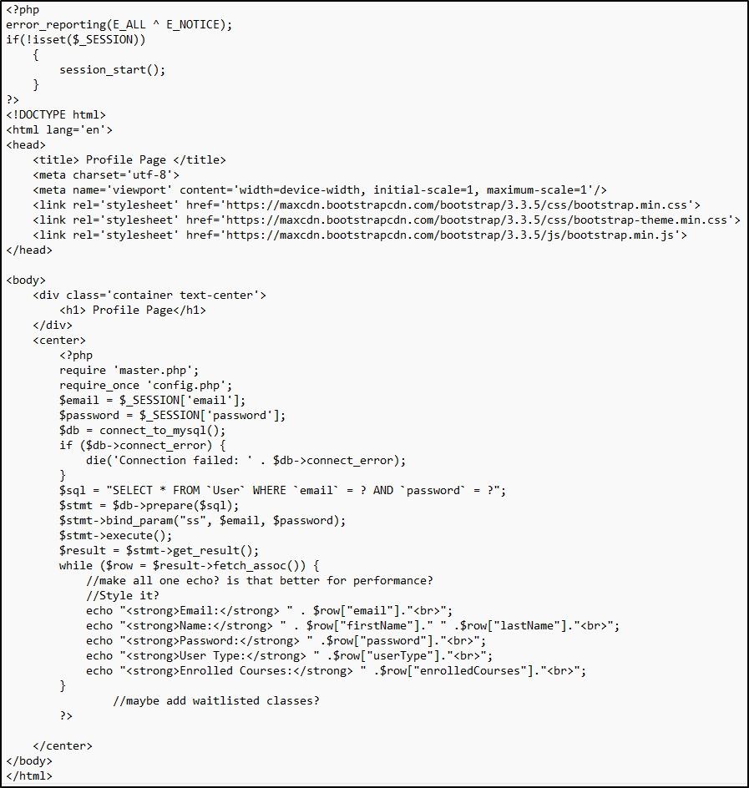

**Course Registration Page PHP Code:** Add or Remove courses

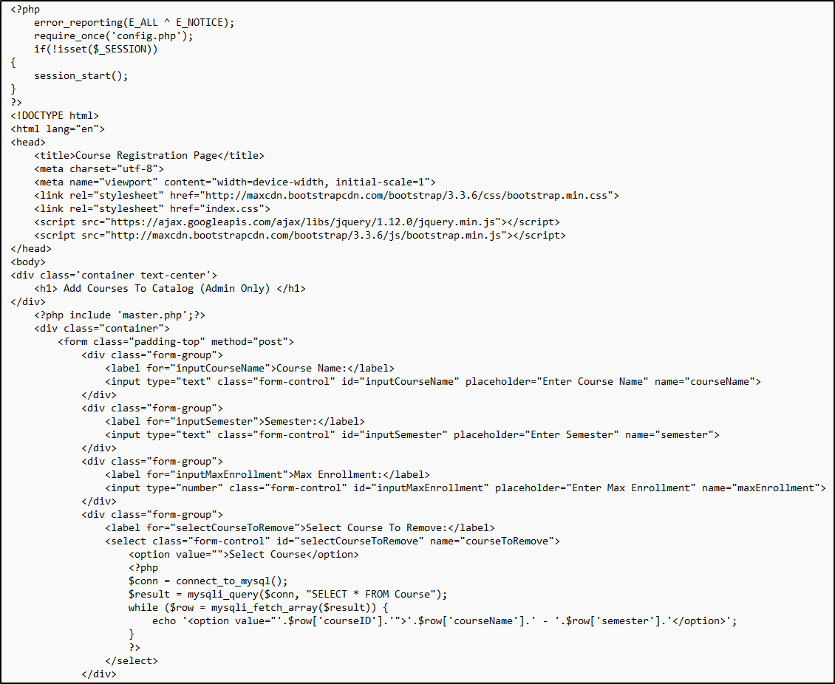

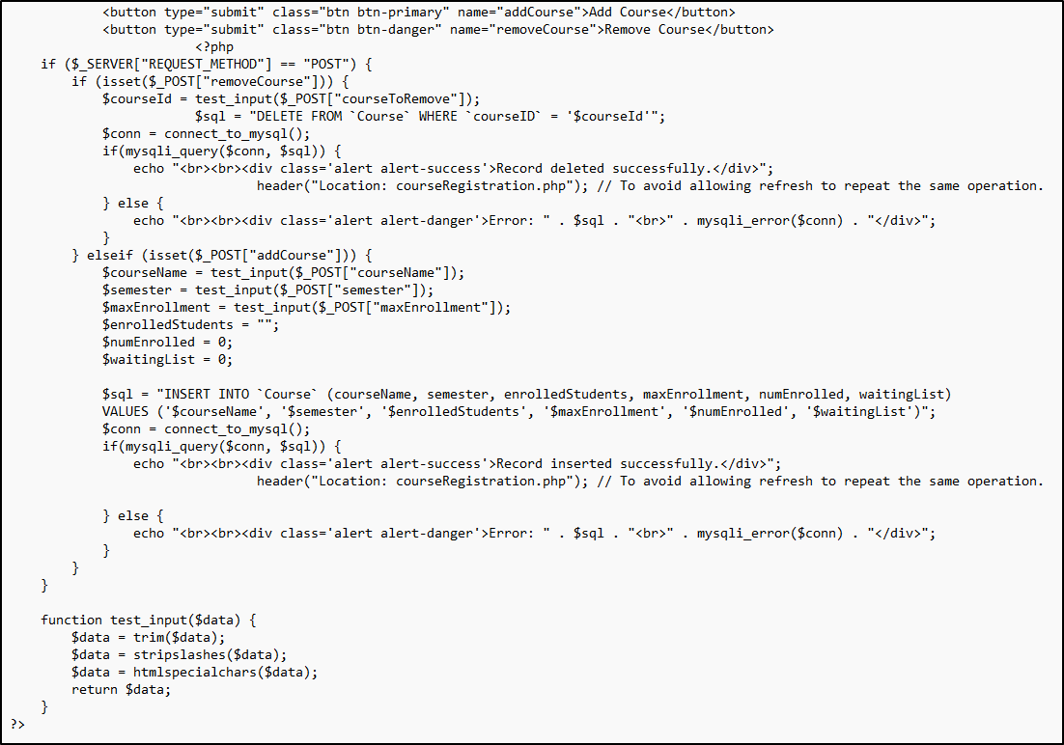

**Contact Us Page PHP Code:**

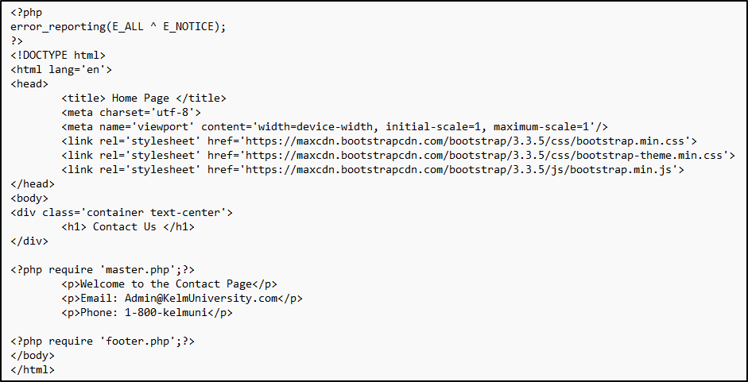

**Admin Page PHP Code:** Admin access to edit course catalog

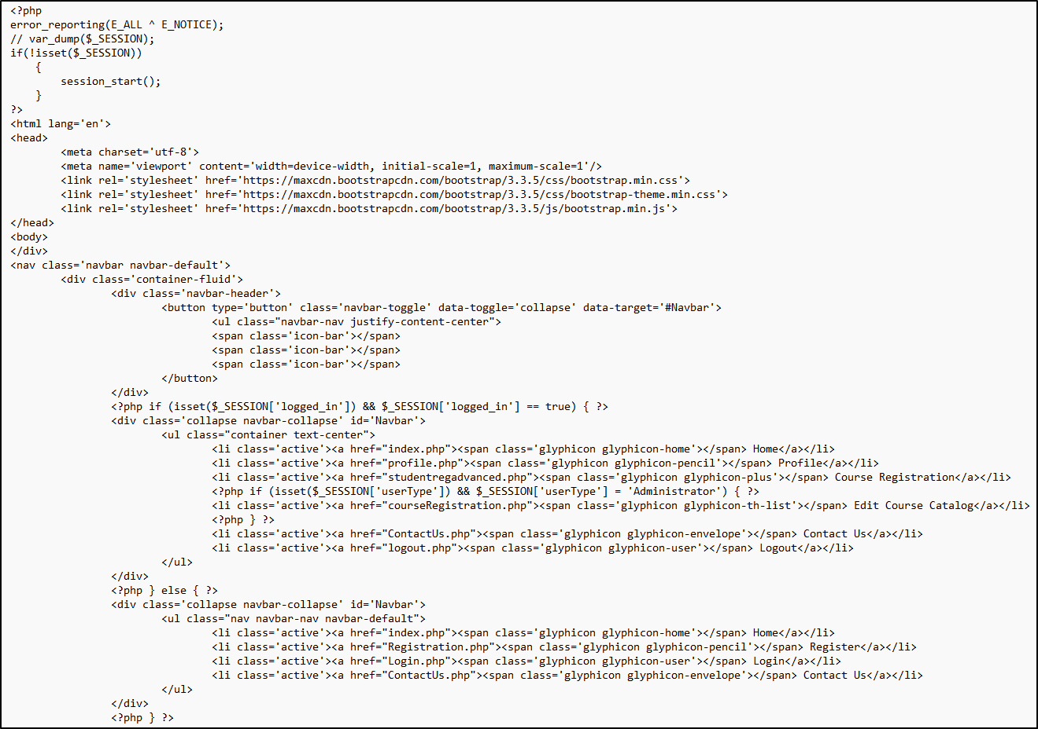

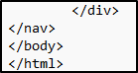

**Connection PHP Code:**

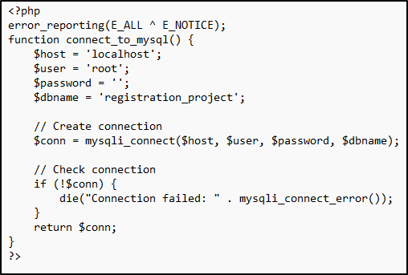

**Course Enrollment PHP Code:**

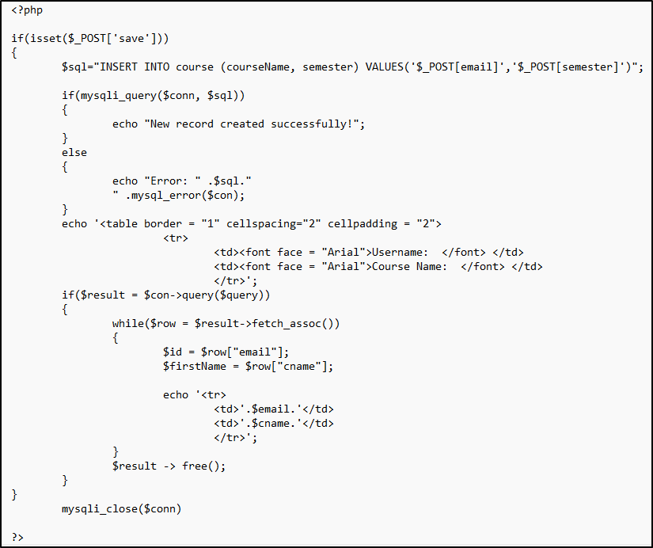

**Landing Page PHP Code:**

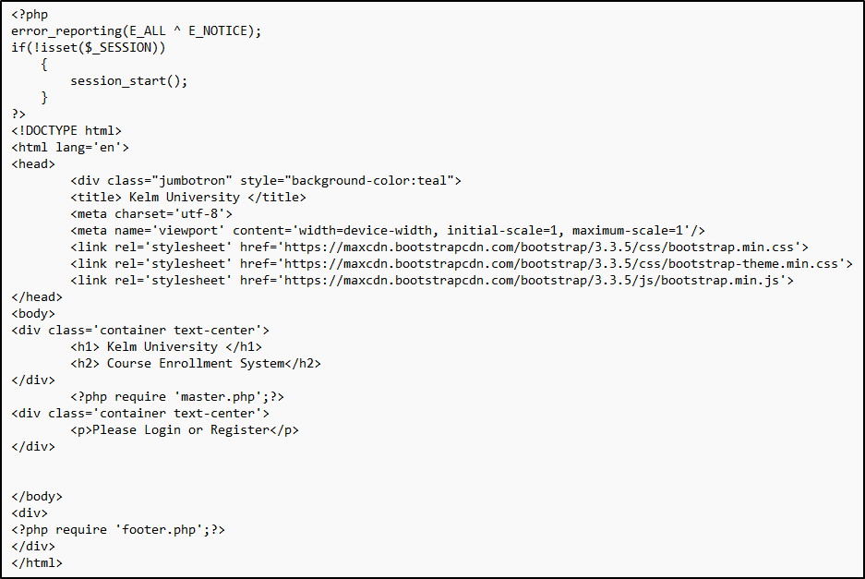

**Footer PHP Code:**

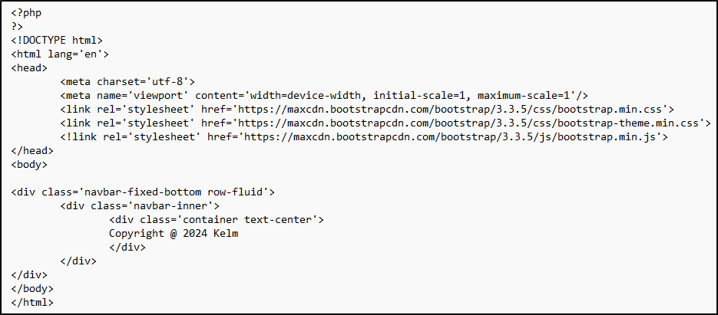

**Login Page PHP Code:**

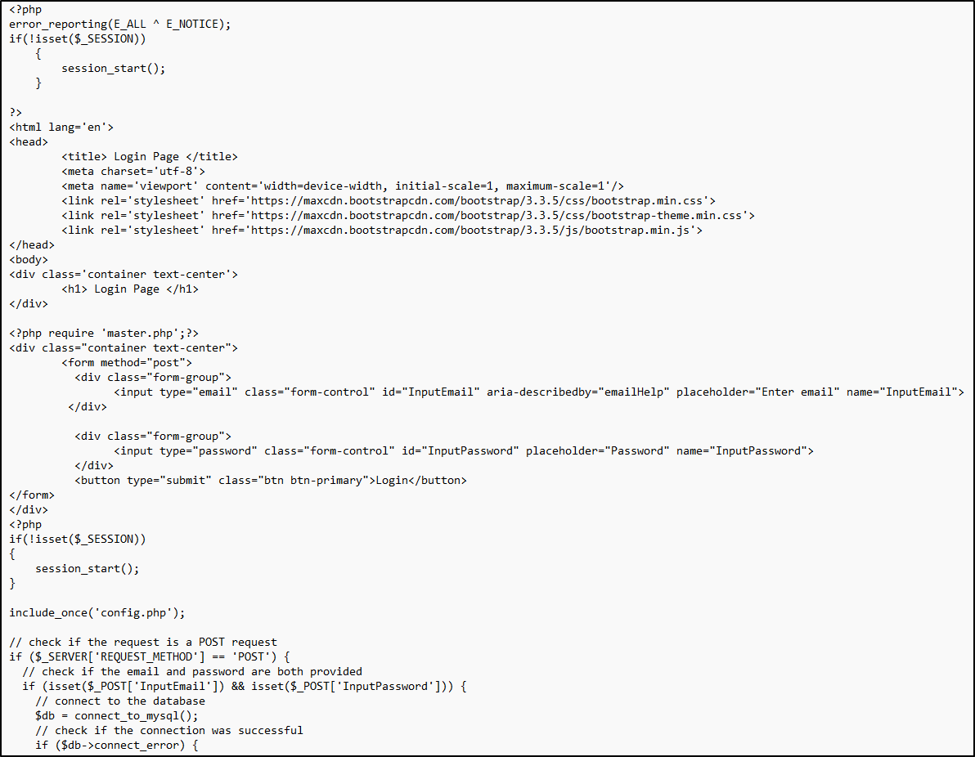

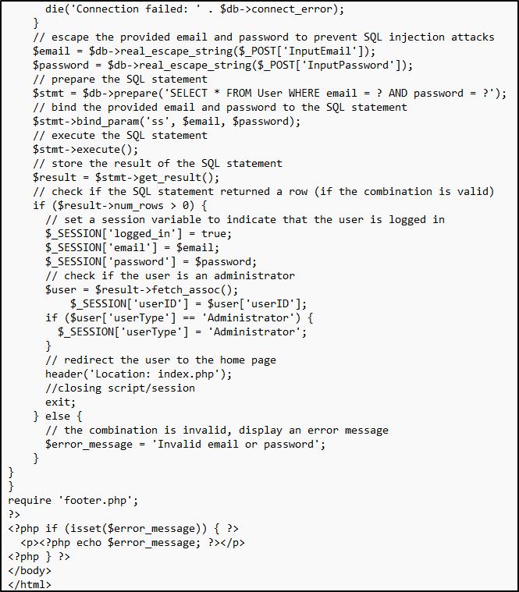

**Registration Page PHP Code:**

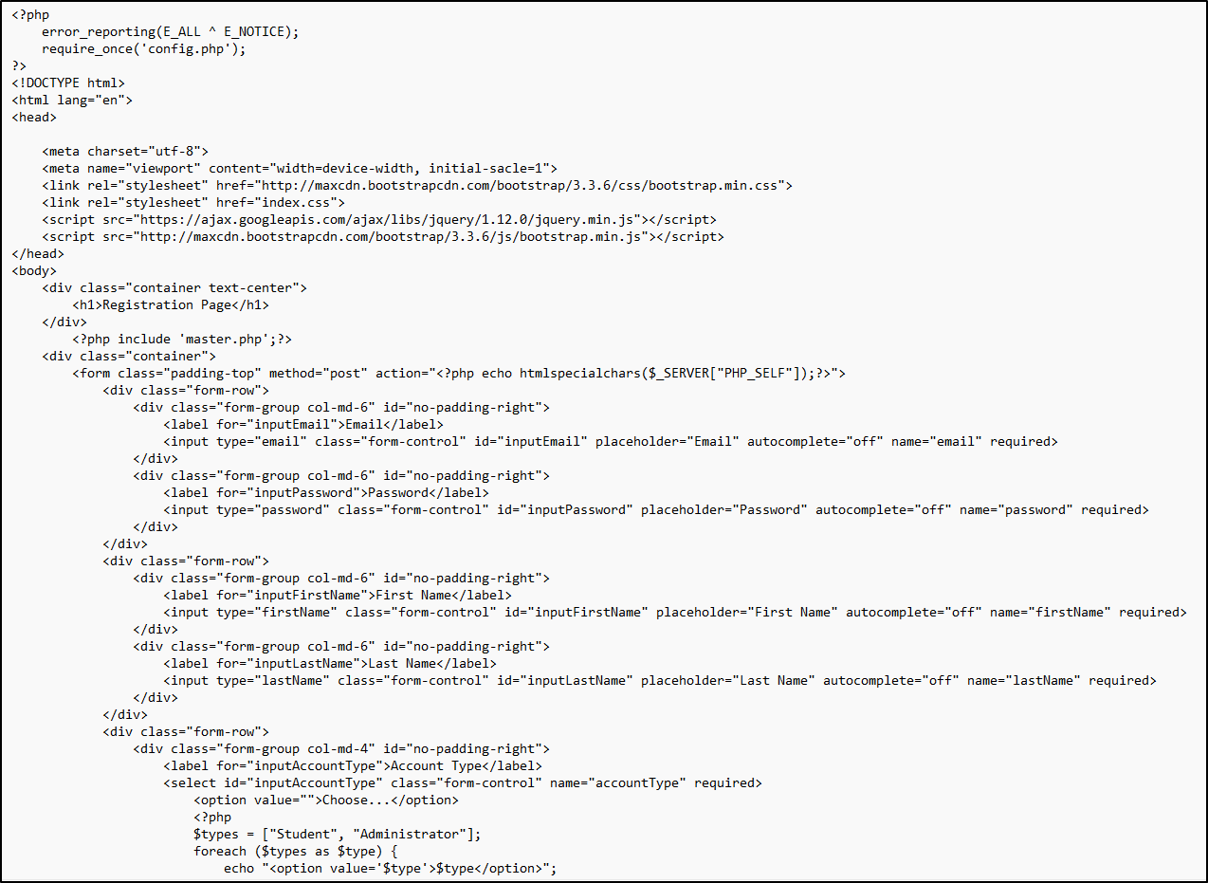

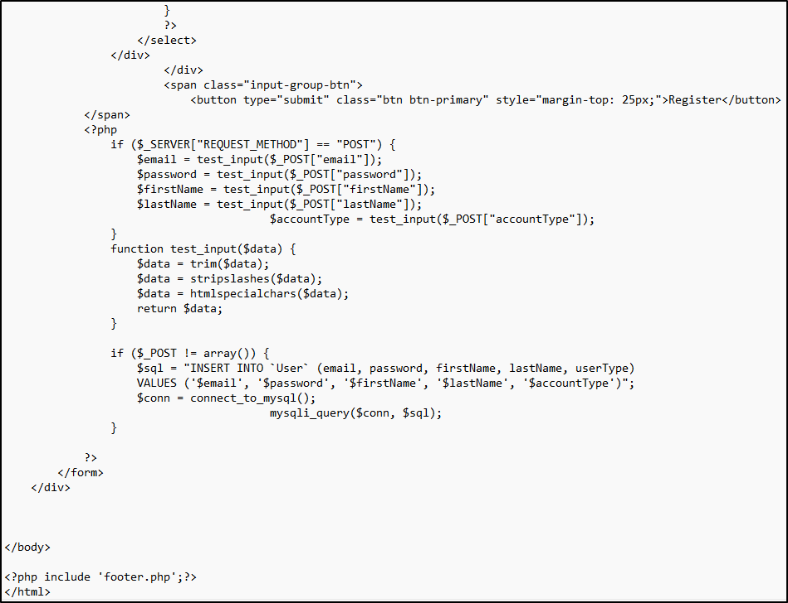

**Summarize the experience going through the implementation phase**

The object of the assignment is the continuation for the development phase of the student enrollment systems started in week 3. In week 3, the student was tasked with creating a website with landing page with login and registration page links, a registration page to create an account in the website database, and a login page used to login to the site after account has been created.

In week 4, the task was to continue building the student enrollment website and add the functionality of user/student login, enrolling in courses, then deleting a course to show that the functionality works as expected. The student was able to register an account on the website, then login after account creation. After the login function was successful, the student was able to enroll in courses provided in the database table “course” and view their profile page showing the enrolled courses. The student was then able to remove the course from their register. Screenshots were provided for each of these steps as well as the source code for each page on the website, and the results as detailed in the tables, “course” and “user”. The functionality created was a success for the Kelm University website.

**Conclusion**

This paper showed the steps in creating the remaining pages for registering for courses, listing enrolled courses for student, adding/removing courses from student, tables and functions for the student enrollment project. Several screenshots were added to include pages created for week 3: landing, login, and registration pages, table layout before adding and after removing a class from a student account, layout, and source code for the new pages created.

**References**

Mikoluk, K. (2013, September 18). [XAMPP tutorial: How to use XAMPP to run your own web serverLinks to an external site.](https://blog.udemy.com/xampp-tutorial). Udemy. https://blog.udemy.com/xampp-tutorial

W3schools. (n.d.). *PHP MySQL Delete Data*. <https://www.w3schools.com/php/php_mysql_delete.asp>

Tsui, F., Karam, O., & Bernal, B. (2018). [Essentials of software engineering](https://uagc.instructure.com/courses/126521/modules/items/6439323)(4th ed.). Jones & Bartlett Learning.